**Chapitre** **11**

# Industrial perspectives

The contribution of this thesis interests several publics. The general public is curious to know about how computer science can help in improving the elderly people’s quality of life at home, since EnTiMid was initially designed for the Ambient Assisted Living context. Everyone has or had a family member who could have been helped by such a proposition. Industrials are more interested by the good properties of the contribution. Since device manufacturers are familiar with electronic components, they easily understand how this component model works.

Starting from the validation scenario, a demonstration of EnTiMid has been set up and presented, in 3 years, in more than 10 public and scientific events. This demonstration stressed the adaptation aspect of the contribution in a AAL context.

## 11.1 Public demonstrations

Public demonstrations are an opportunity for the general public to discover what issues scientists are trying to solve, and how they do it. On the other hand, these meetings are a chance for scientists to collect feedback on their work, from naive persons. Naive, in the sense that they are thinking about the problem for the first time. The questions asked are often very interesting, incite to step back from details, and consider the proposition from a more global view.

The most important presentation was probably the science festival held in 2009 in Rennes, where EnTiMid had been selected to represent the INRIA laboratory. The science festival, *Fêtes de la Science*[1] in French, is a national event lasting for 3 days. From Friday to Sunday included, scientist present their everyday work, explain the problems solved, or the phenomenon involved in some experiments.

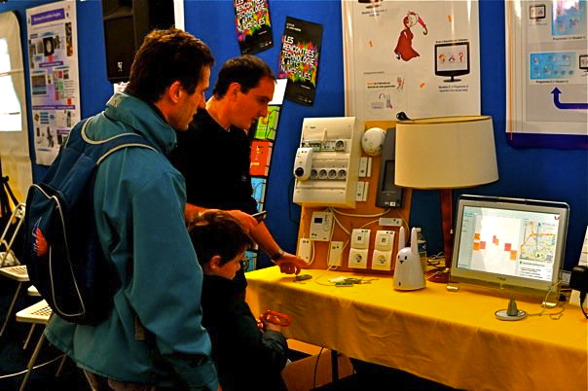

Fig. 11.1: Science festival presentation

During the first day, the festival admits only primary and secondary school children. Visits are organized by groups, and presenters have to explain their work to people aged from 7 to 15 years. This day is the most difficult day of the all festival. Not because the questions are complicated to answer, but because the explanation must be understood by all of them. This first day did not bring a lot of useful comments. At least, less than the two other days.

On Saturday and Sunday, the festival is open, for free, to families, and anybody interested by sciences. These two days were a hard test for EnTiMid, and full of interesting talks with people. Indeed, EnTiMid had to run from 8am to 8pm without failures, in spite of the touch screen stress due to children’s fingers, and in spite of the unpredicted use cases asked in live by visitors.

It was the place for EnTiMid to get enriched by new ideas, remarks, or people experiences in facing elderly people’s dependency problems. Never, for the all duration of the festival, somebody said EnTiMid was useless, meaningless, or that the use case was not realistic. "It is not always that simple in real life" is the only remark we got.

Open days of the University of Rennes 1, or the opening celebration of the ESIR, the newly created engineering school of the University of Rennes 1, have also been two moments for exchanges with a large public. Concerned by the studies, questions of these two events’ visitors were more precise, and more focussed about what had been realized and how.

These demonstrations were sources of very interesting ideas to improve EnTiMid.

Public presentations are very good opportunities to sense how the contribution exposed is perceived by anonymous people. None of them had a negative vision of the work, some had doubts, and others asked about how to buy it. It makes, in my opinion, a validation of the utility of this contribution as perceived by people.

EnTiMid has also been used as support for a demonstration called "*Leveraging Models From Design-time to Runtime. A Live Demo*" described in[**Erreur ! Source du renvoi introuvable.**].

## 11.2 Industrial perspectives

The success of EnTiMid has generated some industrial contacts. Several companies were interested by the abilities of this software to adapt, and evolve at runtime. Most of them, close to the home automation domain, saw in EnTiMid a great opportunity to enrich their products. But EnTiMid was just a proof of concept, a prototype of research not ready to be deployed to the industry. This is partly the reason why EnTiMid was not selected to be deployed in homes, in the IDA project.

Aware of this problem, a project of development of EnTiMid, to make it ready to be used in the industry, had been submitted to the Brittany region, and accepted. This project funded the work of an engineer for a year, whose task was twofold. First, to redevelop some parts of the contribution for it to be more stable, and then, support the promotion of EnTiMid toward the industry. The development methods of EnTiMid have been clarified, and a second demonstration has been set up to focus more the core functionalities, and less the home automation / AAL aspect.

In addition, a project of company creation is currently in progress, and should end with a creation of a structure in charge of the promotion and support of EnTiMid in the next few months. It was also a part of the development engineer’s work to support the creation of this spin-off.

1. See the videos (in French) at http ://videos.rennes.inria.fr/fete-sciences-2009/index.html